**Project Report Template**

**1 INTRODUCTION**

* 1. Overview A brief description about your project

Hnwomio, dosamk,

* 1. Purpose

Kjhewqlkeps

kjhejkwlsl

The use of this project. What can be achieved using this.

**2 Problem Definition & Design Thinking**

2.1 Empathy Map Paste the empathy map screenshot

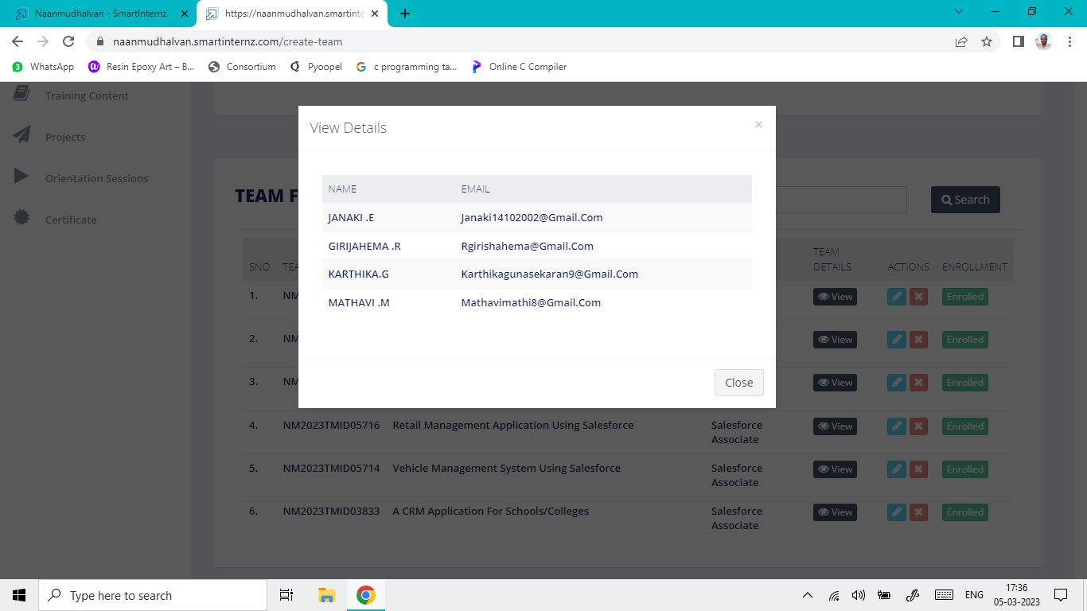

2.2 Ideation & Brainstorming Map

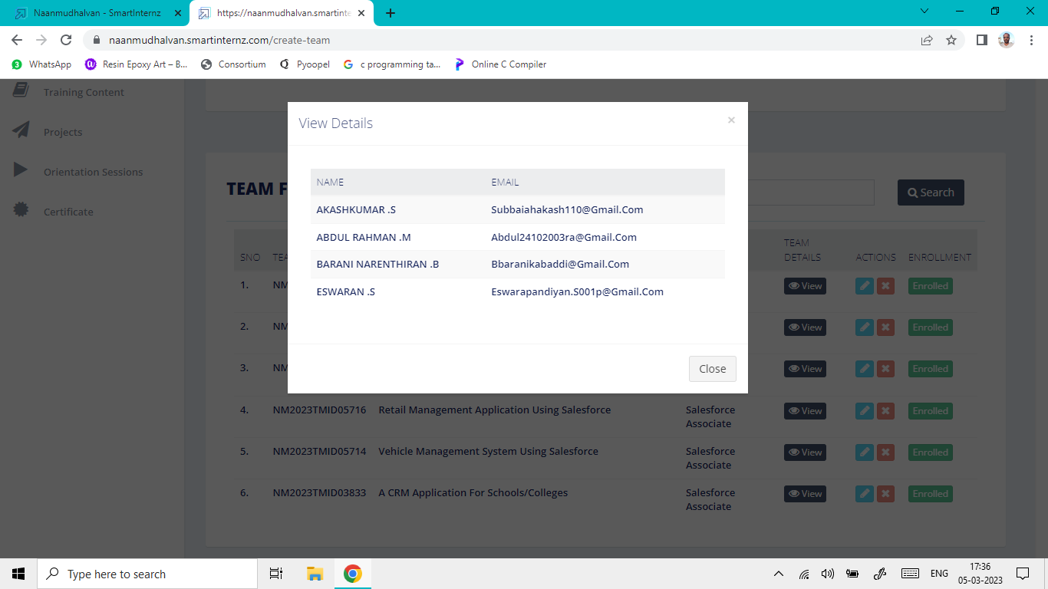

Paste the Ideation & brainstorming map screenshot

**3 RESULTS**

3.1 Data Model:

|  |  |  |  |
| --- | --- | --- | --- |
| **S. No** | **Object Name** | **Fields in Object** | |
| **Field Name** | **Data Type** |
| 1 | Customer | First Name | Text |
| Last Name | Text |
| Date of Birth | Number |
| Phone Number | Number |
| Email | Text |
| 2 | Vehicle Type | Sedan | Text |
| Hatchback | Text |
| SUV | Text |
| Limo | Text |

**3.2 Activity & Screenshot**

1. Object: Customer: The Customer object was created to display the profiles of the customer.

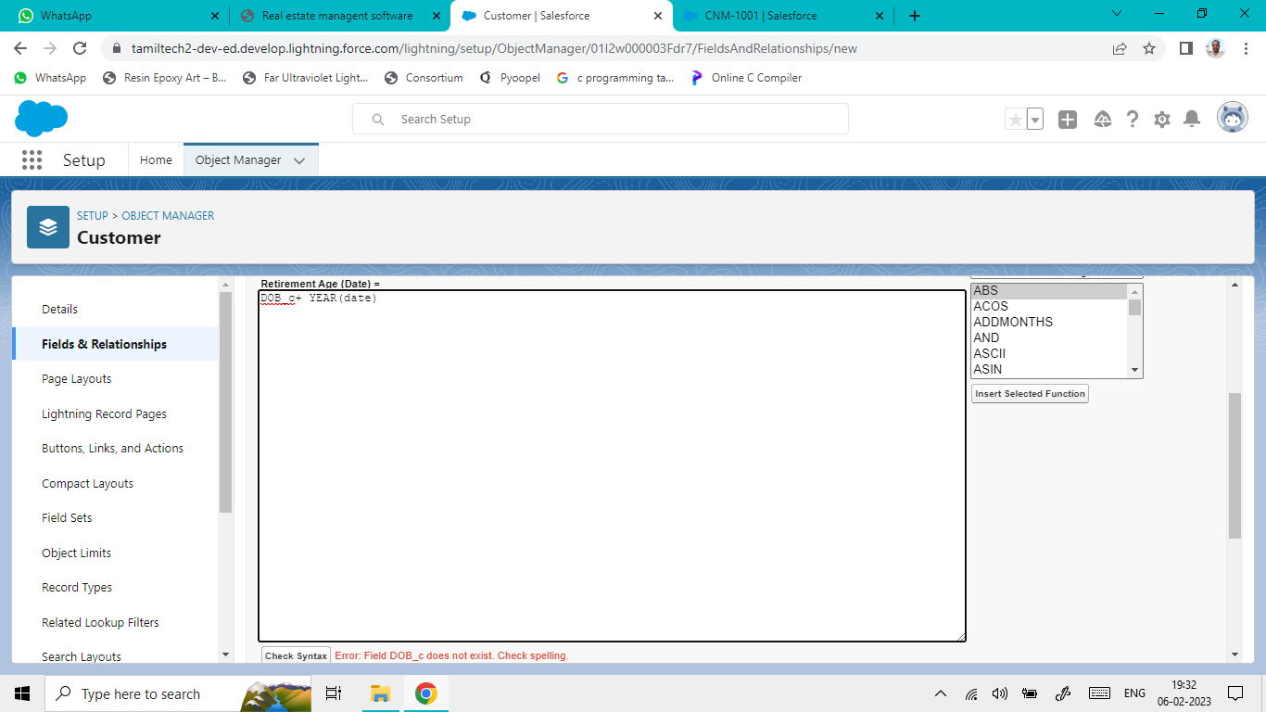

2. Object: Vehicle Type: The Vehicle type object was created to display the type (Shape) of vehicle.